GIANT ROBOT DEATHMATCH!
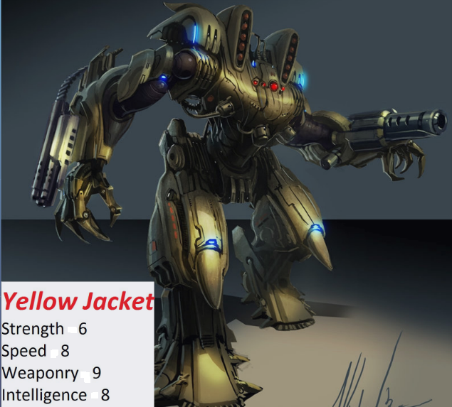 | VS | 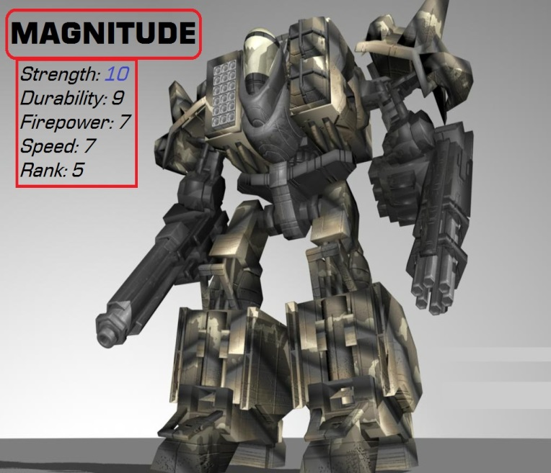

What is Yellow Jacket’s greatest attribute? | What is Magnitude’s greatest attribute?
In an all-out battle, predict which robot would win. Explain your answer. (2-3 compete sent)

Which robot could apply more force (push or pull) to an object? Explain why you think so.

And the winner is ______________________________________!!!

He won because he had greater ___________________.

