MATTER & ATOMS
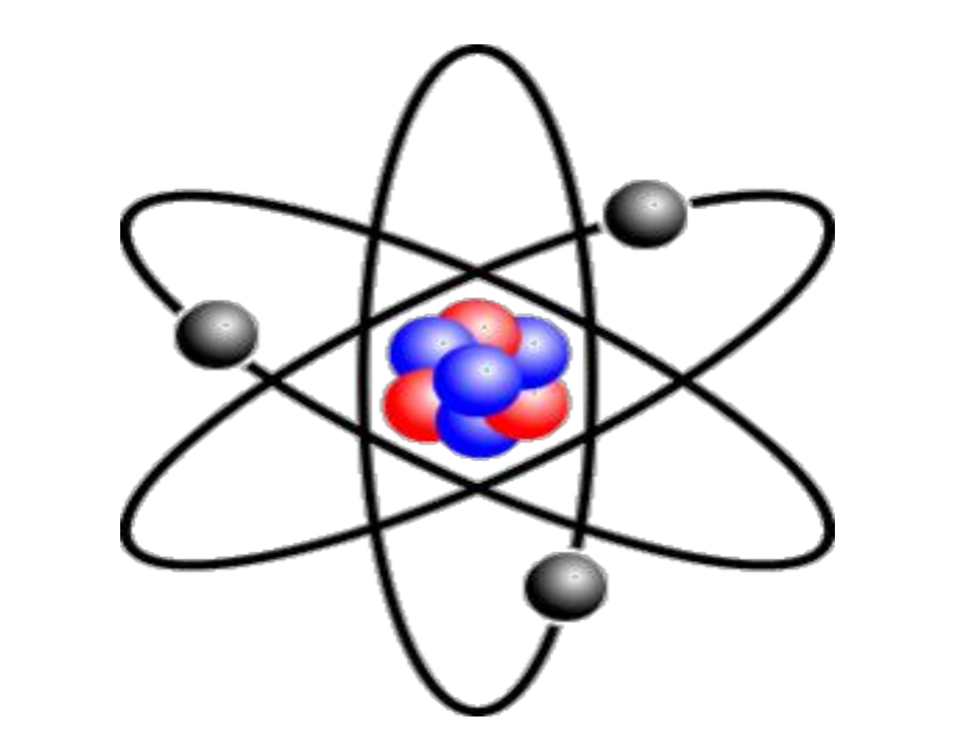
Atoms are the basic building blocks of matter. Atoms can join together to form molecules, which in turn form most of the objects around you. Atoms are composed of particles called protons, electrons and neutrons. Protons carry a positive electrical charge, electrons carry a negative electrical charge, and neutrons carry no electrical charge at all.

Structure of an Atom
The protons and neutrons cluster together in the central part of the atom, called the nucleus. The electrons 'orbit' the nucleus. A particular atom will have the same number of protons and electrons and most atoms have the same number of neutrons as protons.

Atomic Number & Atomic Mass
The number of protons in the nucleus of an atom determines an element's atomic number. In other words, each element has a unique number that identifies how many protons are in one atom of that element. For example, all carbon atoms, and only carbon atoms, contain six protons and have an atomic number of 6.
All atoms have a mass number which is derived as follows.
