Reading Activity – PLATE TECTONICS
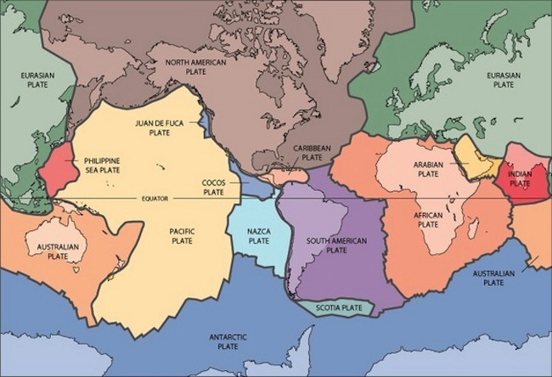
From the deepest ocean trench to the tallest mountain, plate tectonics explains the features and movement of Earth's surface in the present and the past.
Plate tectonics is the theory that Earth's outer shell is divided into several plates that glide over the mantle, the rocky inner layer above the core. The plates act like a hard and rigid shell compared to Earth's mantle. This strong outer layer is called the lithosphere.

Hot material near the Earth's core rises, and colder mantle rock sinks. "It's kind of like a pot boiling on a stove." The convection drive plates tectonics through a combination of pushing and spreading apart at mid-ocean ridges and pulling and sinking downward at subduction zones.

Mid-ocean ridges are gaps between tectonic plates that mantle the Earth like seams on a baseball. Hot magma wells up at the ridges, forming new ocean crust and shoving the plates apart. At subduction zones, two tectonic plates meet and one slides beneath the other back into the mantle, the layer underneath the crust. The cold, sinking plate pulls the crust behind it downward.
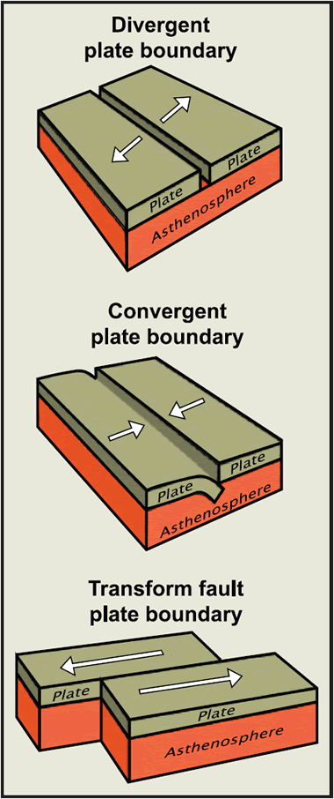
Many spectacular volcanoes are found along subduction zones, such as the "Ring of Fire" that surrounds the Pacific Ocean.

The Plate boundaries
The “subduction zones” are also known as Convergent Boundaries, and are one of the three types of plate boundaries. The others are Divergent and Transform.
At a divergent boundary, two plates are spreading apart, as at seafloor-spreading ridges or continental rift zones such as the East Africa Rift.
Transform boundaries mark slip-sliding plates, such as California's San Andreas Fault, where the North America and Pacific plates grind past each other with a mostly horizontal motion.

